Discussion 3

- A programmer puts the first instruction at address 100H. What happens when the microcontroller is powered up?

Ans:PC=0, CPU fetch the first instruction.and then executes it .

- Show the lowest and highest values (in hex) that the PIC18 program counter can take.

Ans:1F FFFFH

- The design of PIC18 follows ____________ architecture. What are the properties of this architecture?

Ans: Harvard Architecture. Program memory and Data Memory have their individual data and address buses.

- What are the widths of the address bus and data bus of PIC18 program memory? How many memory locations can be addressed by the program memory address bus?

Ans: Program memory (21 bit address bus and 16 bit data bus)

- What are the widths of the address bus and data bus of PIC18 data memory? How many memory locations can be addressed by the data memory address bus?

Ans: Data memory (12 address bus and 8 bit data bus)

- Most instructions allocate only 8 bits to address the data memory, whereas the width of the address bus of PIC18 data memory is more than 8 bits. How can these instructions uniquely specify where operands and destination of an arithmetic/logic operation are located in the memory?
Ans: Bank

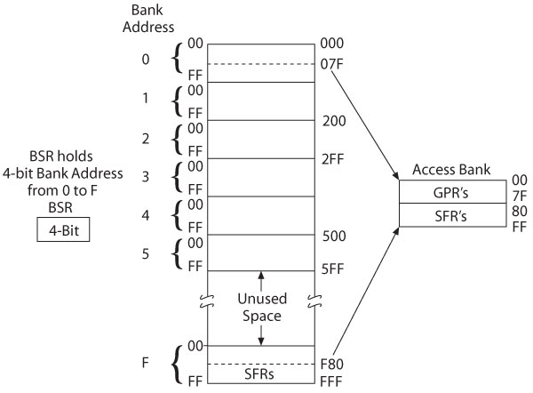

7. Which of the following is (are illegal?

(a) MOVLW 500 | (b) MOVLW 50 | (c) MOVLW 00
(d) MOVLW 255H | (e) MOVLW 25H | (f) MOVLW F5H
(g) MOVLW mybyte, 50H

Ans (a), (d), (f) and (g)

8. Which of the following is (are illegal)?

(a) ADDLW 500 | (b) MOVLW 50 | (c) MOVLW 00
(d) ADDLW 255H | (e) MOVLW 0x12 | (f) MOVLW 0F5H
(g) ADDWL 25H

Ans (a) and (g)

9. What is result of the following code and where is it kopt
MOVLW 25H
ADDLW 0x1F
Ans: MOVLW 25H: WREG=25H
ADDLW 0x15: WREG=25+1F=44H

10. What is result of the following code and where is it kopt
MOVLW 15H
ADDLW 0xEA
Ans: MOVLW 15H: WREG=15H
ADDLW 0x15: WREG=15+EA=FFH
11. The largest number that K can take for the instruction ADDLW K is _________

True or False

12. We have many WREG registers in the PIC!8.
Ans False. There is one WREG only.
13. Data RAM in PIC is called file register
Ans: True
14. The SFRs are part of the file register memory space
True
15. The general purpose RAM is not part of the file register memory space.
False
16. What is the address range fir scratch pad section of access bank?
0-7FH
17. Show a simple code to load values 30H and 97H into locations 5 and 6, respectively.
MOVLW 30H
MOVWF 5H
MOVLW 97H
MOVWF 6H

18. Show a simple code to load value 15H into location 7, and then add to WREG five times and place the result in WREG as the values are added. WREG should be zero before the addition starts.

MOVLW 15H
MOVWF 7H
MOVLW 0F
ADDWF 7H, W
ADDWF 7H, W
ADDWF 7H, W
ADDWF 7H, W
ADDWF 7H, W

19. What is the difference between MOVWF and MOVF instruction?
MOVWF copies the contents of WREG to a location in the file register. MOVF copies the contents of a location in the file register to WREG.

20. What is the difference between MOVFF and MOVWF?
MOVWF copies the contents of WREG to a location in the file register. MOVFF copies the contents of a location in the file register to another file register.
MOVWF is a two-byte instruction. MOVFF is four-byte instruction.

